Historical Geology

Lab2.

Geology Learning Outcomes
By performing and completing this lab, you will progress toward the following learning objectives for this course:
- Think, behave, and communicate scientifically by writing paragraphs that make use of terminology for geologic ages and the principles used by geologists to determine relative and absolute geologic ages, and expressing geologic ages using large numbers and correct units.
- Gather, show, and explain evidence of the earth as a dynamic, ever-changing planet by sequencing, explaining and narrating the geologic history of a geologic cross section. Put geologic events in order and determine the age of geologic materials by applying the principles of relative geologic age.
- Interpret spatial and quantitative information with maps and diagrams by applying principles of relative geologic age to a cross-section diagram of the Grand Canyon.
- Use measurements, numbers, calculations and graphs to derive meaning from the earth by measuring absolute geologic ages using ratios, a graph, and an exponential equation.
- Think, behave, and communicate scientifically.
- Geologic cross section, and relative timing; Sequencing
When you drive along the roads, frequently you can see a road cut which we can interpret as a local "geologic cross-section" -- a side view of the geology at one location. As geologists piece together the information at various outcrops, they can begin to assemble a "geologic map" (like a road map) of an entire region (consisting of many square miles). This map displays the large-scale (also called "regional") geologic features they have inferred are present beneath the landscape.
Along with these geologic maps, we can reconstruct a regional geologic cross-section which would be like a great "geologic slice" through the landscape. In this lab, we will learn how to use local geologic information from outcrops to begin to build such regional geologic maps and geologic cross-sections, but for now we just want to practice how to read them.

You will have to recognize the geologic principles especially the ones which are useful in relative dating. Please remind yourselves from your class notes and make sure you’ll remember them.

1.)Principle of Original Horizontality– Beds of sediment deposited in water form as horizontal (or nearly horizontal) layers due to gravitational settling.
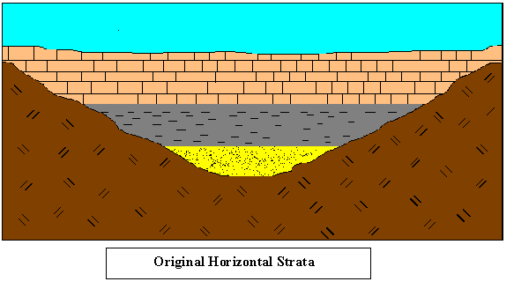
2) Principle of Superposition– In undisturbed strata, the oldest layer lies at the bottom and the youngest layer lies at the top.

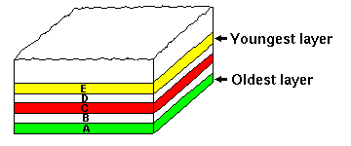

3) Principle of Lateral Continuity– Horizontal strata extend laterally until they thin to zero thickness (pinch out) at the edge of their basin of deposition.
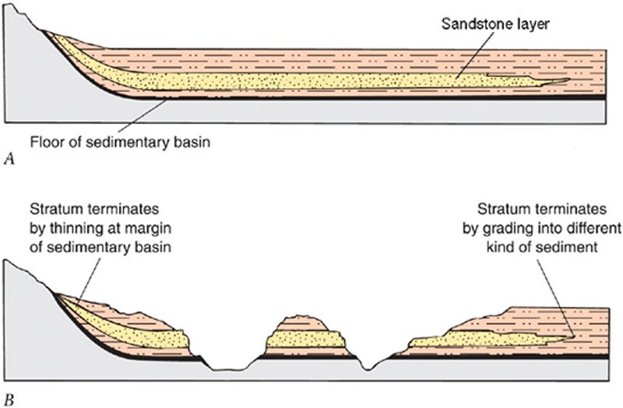

4) Principle of Unconformities– Missing time; Nonconformity, Angular unconformity, Disconformity
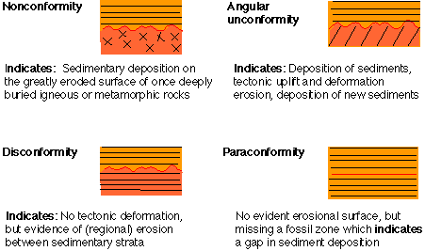

5) Principle of Crosscutting– An igneous intrusion or fault that cuts across a rock unit must be younger than the rocks being intruded or displaced.
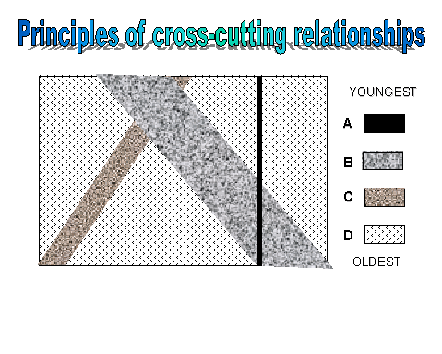
6. Principle of Inclusion- The components of a sedimentary rock must be older than the time when the rock was deposited. Likewise, inclusions in igneous rocks are older than the rocks containing them.
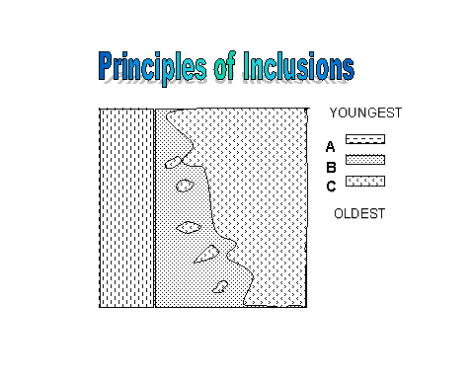

7. Principle of faunal succession
Life-forms on Earth have evolved over time. Species appear, then often go extinct. Fossil assemblages follow one another through time in an orderly and determinable fashion. Because of this, fossils can be used to determine the relative ages of rock units.
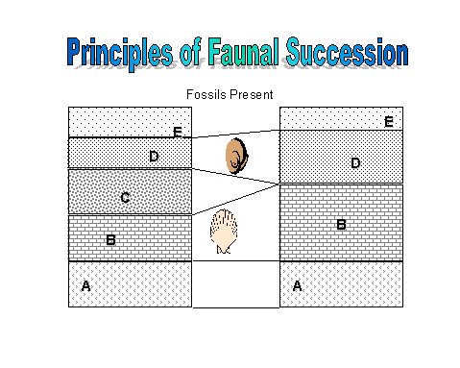

Here is an example of a cross-section with the relative dating.

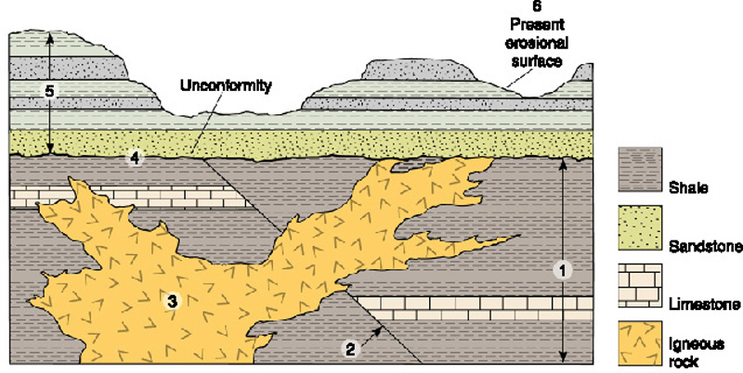

Problems:
- Take a look at the geologic cross-section below. Notice that the various sedimentary layers have been labeled with letters. Also an igneous intrusion is present (labeled T) and a fault is present (labeled A). 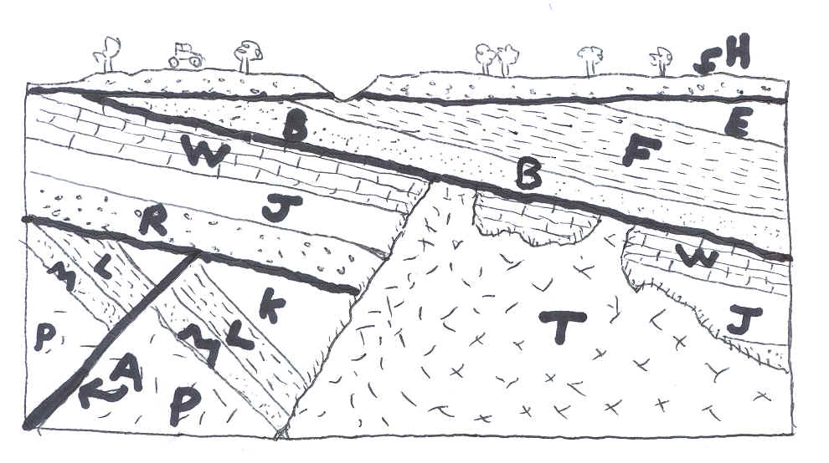
What is the sequence of events (From oldest to youngest) that can be inferred from the above cross-section?

YOUNGEST Write out unconformities, fault etc.

____ _____ ____________

_____H______ ___________

_____E_______ _________ angular unconformity ______________

_____F_______ _______ ___________________

_____B_______ _______ ________

_____T_______ _______ ___________________

_____W_______ _____ disconformity and nonconformity ______

_____J_______ _______ _____________

_____R_______ _________________________________________

_____A______ _____angular unconformity__________________

_____K_______ ______ ______________

_____L_______ ______ __________

_____M_______ ________________

_____P_______ ___nonconformity_________________________

Oldest

- Take a look at the geologic cross-section below. Notice that the various sedimentary layers have
Been labeled with letters along with the unconformities. You have to put them in as separate events.

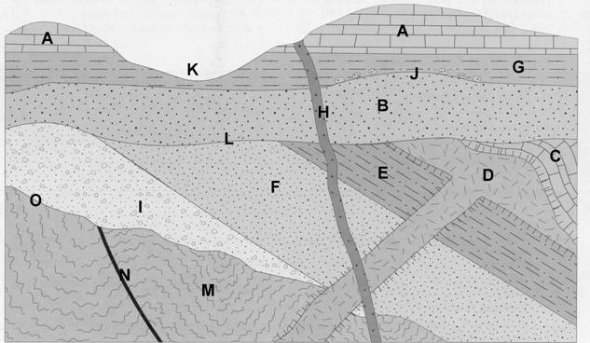

YOUNGEST Write out unconformities, fault etc.

_____K_______ _________________________________________

_____H_______ _________________________________________

_____A_______ _________________________________________

_____G_______ _________________________________________

_____J_______ _____________ disconformity ______________

_____B_______ ___________ angular unconformity _____________

_____L_______ _________________________________________

_____C_______ _____ ________________

_____D_______ _________________________________________

_____E_______ _________________________________________

_____F_______ _________________________________________

_____I_______ ________disconformity____________

_____O_______ _________________________________________

_____N_______ _________________________________________

_____M_______ _________________________________________

Oldest

- Take a look at the geologic cross-section below. Notice that the various sedimentary layers have been labeled with letters.

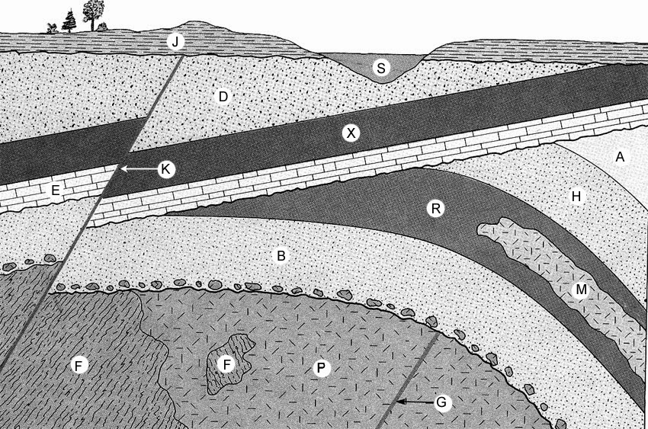

YOUNGEST Write out unconformities, fault etc.

____________ _________________________________________

_____S_______ _________________________________________

_____J_______ _____________Disconformity______________

_____K_______ _________________________________________

_____D_______ ___________Angular unconformity___________

_____X_______ _________________________________________

_____E_______ _________________________________________

_____A_______ _________________________________________

_____H_______ _____________Disconformity_________

_____M_______ _________________________________________

_____R_______ _________________________________________

_____B_______ _______________Disconformity______________

_____F_______ _________________________________________

_____G_______ _________________________________________

_____P_______ _________________________________________

Oldest

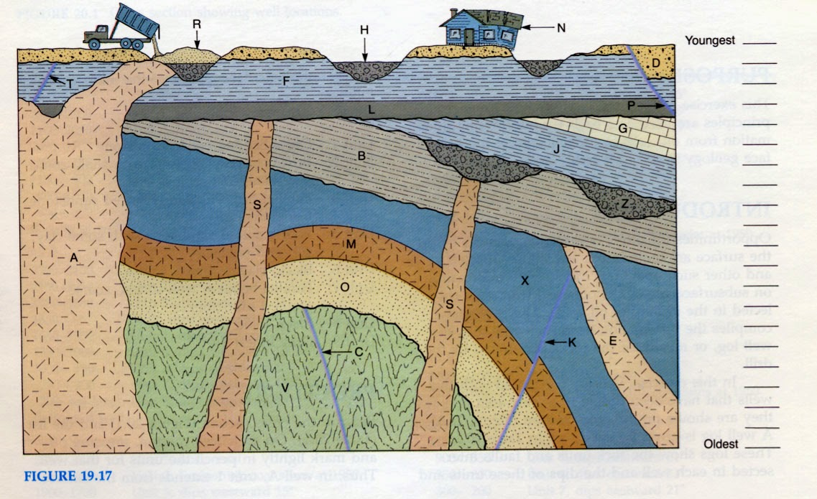

YOUNGEST Write out unconformities, fault etc.

____R________ _________________________________________

____N________ _________________________________________

____P________ _________________________________________

____D________ _________________________________________

____H________ _Angular unconformity and Nonconformity____

____T________ _________________________________________

____A________ _________________________________________

____F________ _________________________________________

____L________ _________________________________________

____J________ _________________________________________

____Z________ __________________________________________

____S________ _____________nonconformity_______________

____B________ _________________________________________

____E________ _________________________________________

____X________ _________________________________________

____K________ _________________________________________

____M________ _________________________________________

____O________ __________Disconformity___________________

____C________ _________________________________________

____V________ _________________________________________

Oldest

- Absolute Geologic time

PART 1. Working With Graphs ( Practice graphing)
How Fast is a Liquid Cooled? Plot the data on the graph below, with time on the X-axis and temperature on the Y-axis.
1. What information does the graphs contains? __contains the temperature on y-axis and time on the x-axis ____
2. At time 4 minutes after, what is the temperature of the liquid? _____20ºC________
3. At time 12 minutes, what is the temperature of the liquid? _______ -15ºC______
4. How long will it take to cool this liquid from 40º C to -30º C? ______15min________
5. At what times will the liquid cool to the following temperatures?
20 º C ______4min______ -10 º C ___11min_____ -35 º C __16min____
6. How long will it take for the liquid to cool down from 5 º C to -5 º C? ____3min___
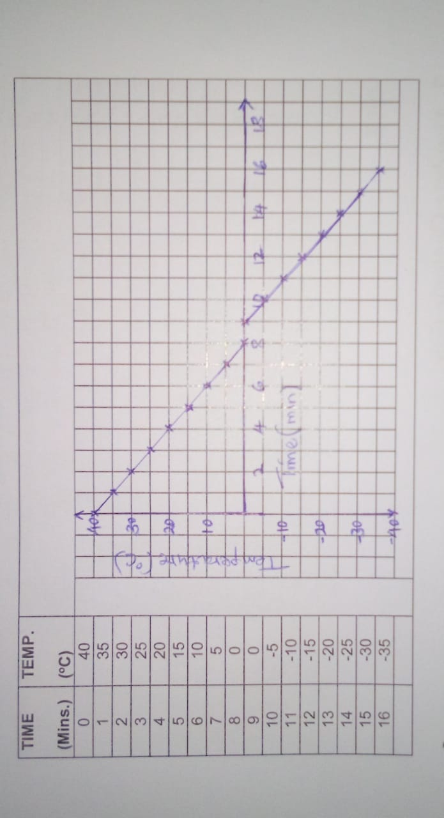

Important concepts
- First, for each parent isotope decay one daughter isotope is created.
- Secondly, it is important to notice in the rate expression that the number of decays is not a constant function of time (say for example the way a second is always 1/60th of a minute). Rather, the number of decays over a given time period changes with the number of parents present (simple example: 1/2 the students leave every 5 minutes during this lecture). Thus, decay is not a linear function of time, rather it is ‘curved’. The concept of half-life (t _{1/2}) is an important concept to remember. Half-life is the time required for half of the substance to decay to a stable daughter.
This graph illustrates two major points regarding radiometric dating:

- First, the point of intersection between the parent and daughter curves (both have equal no. of atoms) illustrates the concept of a half-life.
- Second, this exercise graphically represents the change in Parent-Daughter ratio with time. With every half-life, there will be less parent atoms and correspondingly more daughters.
Plot the parent daughter curves on the graph below based on the values of their abundances with time (in half-lives).
Use different color for parent and daughter isotopes.
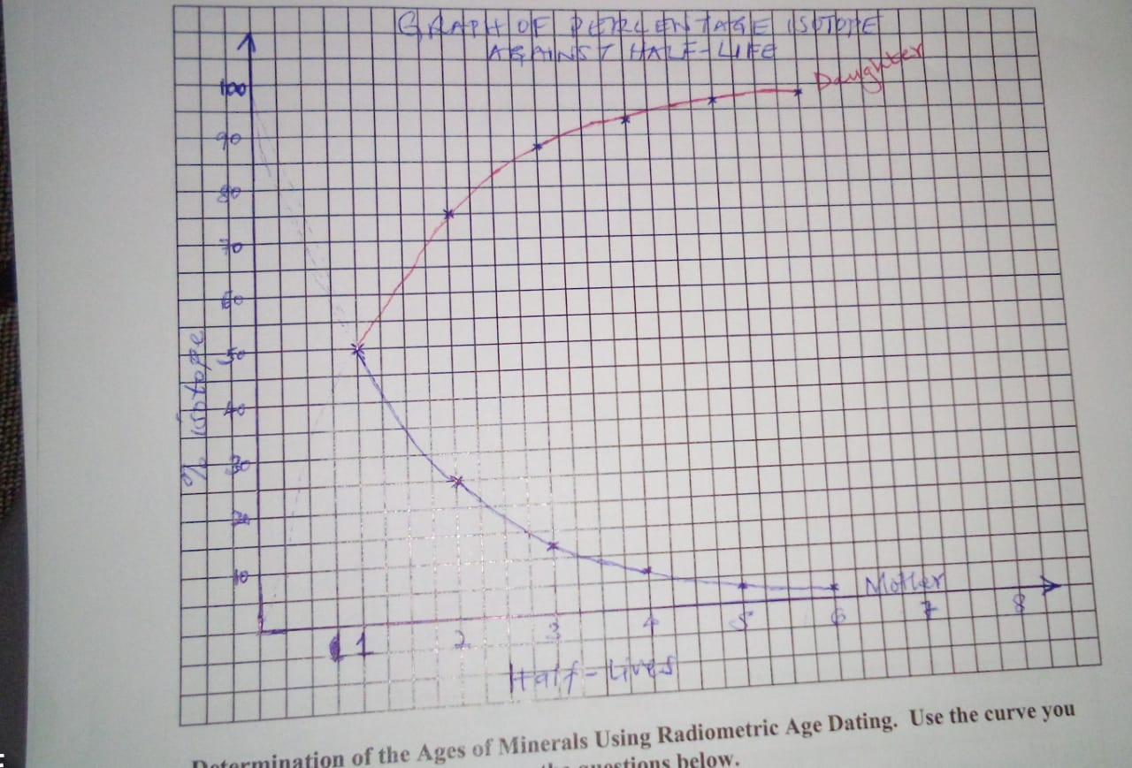
Half- life should be on the X axis, and % of the isotopes on the Y axis.  Isotope Pair concentration (%) | No. of Half-lives
 | 1 | 2 | 3 | 4 | 5 | 6
Parent | 50 | 25 | 12.5 | 6.25 | 3.125 | 1.563
Daughter | 50 | 75 | 87.5 | 93.75 | 96.875 | 98.437
Determination of the Ages of Minerals Using Radiometric Age Dating. Use the curve you just constructed above to answer the questions below.
Common Radiometric Isotopes | Amount of Parent Isotope Remaining (in %) | Amount of Stable Daughter Isotope Produced (%) | No. of Half-lives Measured | Half -Life (Years) | Age of Mineral
²³⁸U& ²⁰⁶Pb | 50 | 50 | 1 | 4.5 billion | 4.5b
²³⁵U& Pb²⁰⁷ | 25 | 75 | 2 | 713 million | 1.42b
²³²Th& ²⁰⁸Pb | 90 | 10 | 0.1 | 14.1 billion | 1.41b
⁸⁷Rb & ⁸⁷Sr | 75 | 25 | 0.25 | 47 billion | 11.75b
⁴⁰K& ⁴⁰Ar | 40 | 60 | 1.2 | 1.3 billion | 1.56b
¹⁴C& ¹⁴N | 10 | 90 | 3.2 | 5730 | 18336years
How did you determine the age of the mineral that contains a particular radioactive isotope parent daughter pair,? Multiply age measured for half-lives with half-life ________
PART 2. Lets put the two method together!
In this part you will be asked to calculate the absolute ages of three different rocks shown on the geologic cross-section below. These units are A–the basaltic dike, B–the granite, and C–the folded metamorphic rock (ignore the two sandstone layers for this exercise).

Isotopic analyses have been carried out on minerals separated from the three crystalline rocks A, B, and C. These data are listed below the cross-section in Table 1. To calculate the ages of the units, you will need to understand the principles of radiometric dating that you learned in lecture. In this problem, we will be using the potassium-argon system; potassium-40 has a half-life of 1.25 billion years. Please read the information on the back of this page and answer the questions printed there. Please show all of your mathematical work, and put a box around each of your final answers.

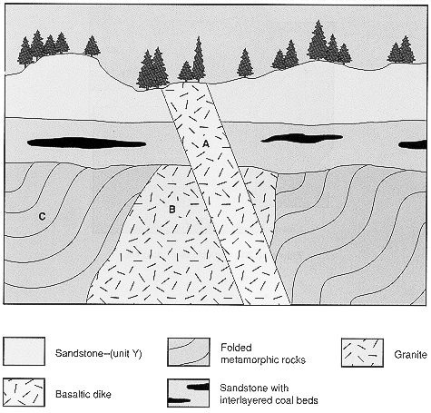

TABLE 1. Results of Isotopic Analyses:

Rock Unit Number of Parent Atoms Number of Daughter Atoms

A 7497 1071
B 11480 3827
C 839 2517

You have learned the principle of radiometric dating: radioactive parent isotopes decay at a constant rate and slowly become stable daughter isotopes. The decay rate is stated in terms of half-lives: the time it takes for one-half (50%) of the parent isotope to decay into the daughter isotope is called the half-life. As the rock ages, the amount of the parent isotope will decrease and the amount of the daughter isotope will increase geometrically (not linearly). Graphs of radioactive decay clearly show this geometrical or exponential decay. To determine the age of an unknown rock, you need to measure the number of parent and daughter atoms in a sample (this data is given to you in the table). The ratio of the daughter atoms to the parent atoms is proportional to the age. But if you know the half-life as well as the number of atoms of both isotopes, you can calculate the age in years—an absolute age. You need to use the following formula:

P% is the percent of initial parent atoms remaining in the system; Po is the number of parent atoms originally present when the rock formed; Pt is the number of parent atoms today (see table); Dt is the number of daughter atoms today (see table). Obviously, the total of the parent and daughter atoms today is equal to the number of parent atoms when the rock formed, since each daughter atom came from a parent atom. When you divide the number of parent atoms today by the number of parent atoms originally, you will get a ratio, such as 1/4 (= 25%) or 1/2 (= 50%). This ratio is the percent of parent atoms remaining in the system today, and is directly related to the number of half-lives that have transpired since the rock crystallized from magma.

Please answer the following questions. Please show all your work: write your equations, values, and calculations. You may use a calculator. To answer the relative age question, use the attached geologic time scale. (If a relative age falls on a boundary line between two time units, state this fact and name both units.)

1. What is the absolute age of the basaltic dike, unit A? What is the relative age (eon, era, period)?

Original is 7497+1071=8568
%atom is 7497/8568*100=87.5%
Time is 0.1
Half-life is 1.25b years
Age is 0.1*1.25=0.125b years.

2. What is the absolute age of the granite, unit B? What is the relative age (eon)?

Original is 11480+3827=15307
%atom is 11480/15307*100=75%
Time is 0.5
Half-life is 1.25b years
Age is 0.5*1.25=1.875b years.

3. What is the absolute age of the folded metamorphic rock, unit C? What is the relative age (eon)?
Original is 839+2517=3356
%atom is 839/3356*100=25%
Time is 2
Half-life is 1.25b years
Age is 2*1.25=2.5b years.
4. What is the most likely relative age of the coal bed?
Between 0.125billion years and 1.875billion years
5. what is the most likely age of the top sandstone layer?
Less than 0.125billion years

